UI/UX INTERNSHIP PROJECT

ShopEase
Designing a mobile shopping experience, one wireframe at a time
Internship | UI/UX Design Intern at Thiranex
Project | ShopEase – mobile e-commerce app
Deliverable | Low-fidelity wireframes for the core shopping journey
Tool used | Figma
Screens designed | 5 (Welcome, Home, Product Details, Cart, Order Confirmation)

Introduction
During my internship at Thiranex, I got the chance to work on something I’d been wanting to try for a while: designing a complete user flow for a mobile app from scratch. The app I worked on is called ShopEase, a simple shopping app with the tagline “Unpack your new favourite thing.”
This document is my way of walking through that work. It covers how I approached the project, the thinking behind each screen, and what I learned along the way. The wireframes are shown in the order a shopper would experience them, from opening the app to placing an order.

Project Overview

The goal
The aim was to design an easy, friction-free shopping journey on mobile. A person should be able to open the app, find something they like, choose a size, add it to the cart and place an order without ever feeling lost or having to think about what to do next.

Why wireframes first?
Before thinking about colours, fonts or photography, I wanted to get the structure right. Wireframes let me focus purely on layout, hierarchy and flow. That is why everything here is in greyscale, with placeholder boxes standing in for images and grey bars for text. It keeps the conversation about “does this work?” rather than “does this look pretty?”

Tools
All the wireframes were created in Figma. I used its frames, auto-layout and reusable components, so things like the bottom navigation bar, buttons and product cards stayed consistent from one screen to the next.

My Design Process

I didn’t jump straight into drawing screens. I tried to work in a sensible order, and here is roughly how it went.
Step 1: Understanding the flow. I started by thinking about what a typical shopper does in an e-commerce app, and boiled it down to five moments: arrive, browse, choose, review and confirm.
Step 2: Mapping the screens. Each of those moments became one screen. Keeping the number of screens small helped me focus on the essentials rather than adding features for the sake of it.
Step 3: Sketching the layout. For each screen I decided what the most important element was, placed it where it would be noticed first, and arranged the rest around it.
Step 4: Building in Figma. I turned the layouts into clean, low-fidelity frames using the same grid, spacing, icons and button styles throughout.
Step 5: Reviewing for consistency. Finally, I went back through all the screens as a set, checking that navigation, button hierarchy and spacing felt like they belonged to the same app.

The User Flow at a Glance

Here is the whole journey in one view. A shopper starts at the welcome screen, lands on the home page, opens a product, adds it to the cart and finishes with an order confirmation.

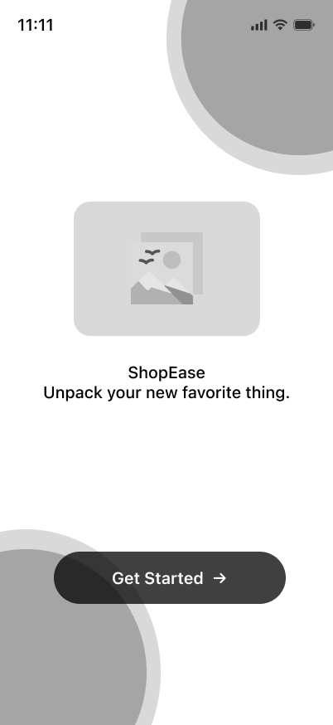 | 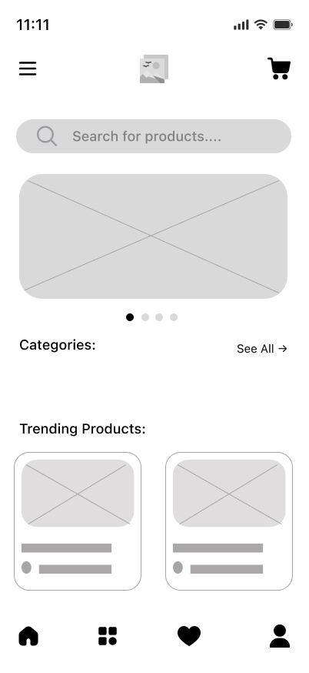 | 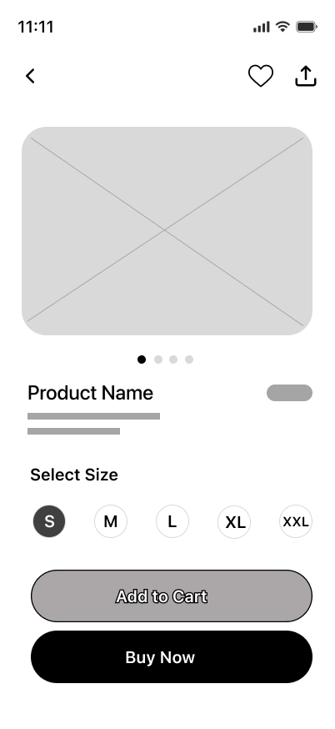 | 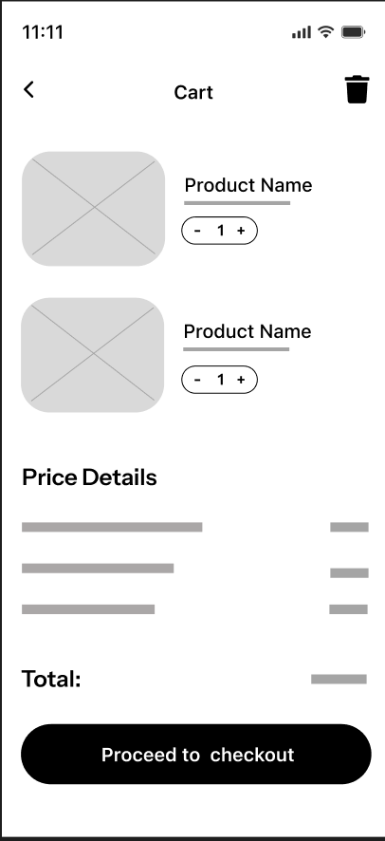 | 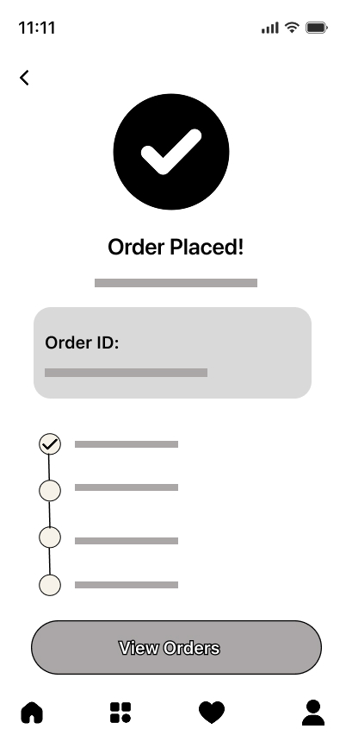
1. Welcome | 2. Home | 3. Product Details | 4. Cart | 5. Order Confirmation
Welcome → Home → Product Details → Cart → Order Confirmation

Screen-by-Screen Walkthrough
Now let’s go through each wireframe in order, looking at what’s on the screen and why I made the choices I did.

Screen 1: Splash / Welcome Screen
Figure 1. Splash / Welcome Screen | The first thing a person sees when they open ShopEase.  What’s on the screen  - A logo placeholder in the centre with the app name and the tagline “Unpack your new favorite thing.”  - A single, bold “Get Started” button near the bottom, with a small arrow to hint at moving forward.  - Large soft circles in the top-right and bottom-left corners to add some visual interest without cluttering the screen.  Why I designed it this way  I wanted the welcome screen to feel calm and uncluttered. There is only one thing to do here, so there is only one button. Keeping the call-to-action in the thumb zone makes it easy to tap with one hand.

Screen 2: Home Screen
Figure 2. Home Screen | The main hub where shoppers browse and discover products.  What’s on the screen  - A top bar with a menu icon, the logo in the middle and a cart icon on the right.  - A prominent search bar right under the header.  - A banner carousel (with pagination dots) for offers and highlights.  - A “Categories” row with a “See All” link, followed by a “Trending Products” section with product cards.  - A bottom navigation bar with Home, Browse, Favourites and Profile.  Why I designed it this way  Search comes first because many shoppers already know what they want. Everything else is arranged in the order a browsing shopper would naturally scroll through: promotions, categories, then trending items. The bottom navigation keeps the main sections within easy reach.

Screen 3: Product Details Screen
Figure 3. Product Details Screen | Where a shopper looks closely at an item and decides whether to buy it.  What’s on the screen  - A large image area with pagination dots, so more than one product photo can be shown.  - Back, favourite (heart) and share icons at the top.  - The product name, a price tag placeholder and a short description.  - A “Select Size” row (S, M, L, XL, XXL) with the selected size clearly highlighted.  - Two buttons at the bottom: “Add to Cart” and “Buy Now”.  Why I designed it this way  The product image gets the most space because it is what sells the item. I gave the two buttons different visual weights on purpose: “Buy Now” is solid black as the primary action, while “Add to Cart” is the lighter secondary option for people who want to keep browsing.

Screen 4: Cart Screen
Figure 4. Cart Screen | A quick review of everything the shopper has picked before they pay.  What’s on the screen  - A list of the items in the cart, each with a thumbnail, product name and a quantity stepper (– / +).  - A delete icon in the top corner for clearing the cart.  - A “Price Details” section with line items and a clearly separated total.  - A full-width “Proceed to checkout” button anchored at the bottom.  Why I designed it this way  People come to the cart to double-check and adjust, so quantity controls sit right beside each item. Showing the price breakdown and total before the checkout button helps avoid surprises and builds trust.

Screen 5: Order Confirmation Screen
Figure 5. Order Confirmation Screen | The reassuring final step once an order has gone through.  What’s on the screen  - A large check-mark icon and an “Order Placed!” heading, so the result is clear at a glance.  - An Order ID card for reference.  - A vertical progress tracker showing the stages of the order, with the first step already ticked.  - A “View Orders” button, and the bottom navigation for moving elsewhere in the app.  Why I designed it this way  After paying, people want to know one thing: did it work? The big check mark answers that immediately. The progress tracker sets expectations about what happens next, which cuts down on that anxious “where is my order?” feeling.

Design Decisions That Run Through the Whole App
- Consistency. The same bottom navigation, rounded cards and pill-shaped buttons appear across the screens, so the app feels familiar quickly.
- Clear button hierarchy. Black, solid buttons mark the main action on a screen, while lighter grey buttons mark secondary actions.
- Thumb-friendly layout. Primary buttons sit in the lower part of the screen where a thumb can reach them comfortably.
- Whitespace and simplicity. Generous spacing and a restrained greyscale palette keep each screen focused on one task.
- Low-fidelity on purpose. Placeholders for images and text let me focus on structure. Colours and real content can be layered on later.

Challenges and What I Learned
Designing a simple flow turned out to be harder than I expected. The real challenge was deciding what to leave out. It’s tempting to add filters, reviews, recommendations and more to every screen, but each extra element competes for attention. Learning to prioritise was probably my biggest takeaway.
I also got much more comfortable with Figma, especially components and auto-layout, which saved a lot of time when I needed to adjust something that appeared on several screens. And I learned that thinking about the order of screens, not just each screen on its own, makes a big difference to how natural an app feels.

Next Steps
These wireframes are a foundation, not the finished product. If the project continued, here is what I would do next:
- Turn the wireframes into a clickable Figma prototype so the flow can be tested end to end.
- Add the missing screens, such as login, categories, search results, checkout and address entry, payment, and order history.
- Test the prototype with a few real users and refine the design based on their feedback.
- Move into high-fidelity design with colours, typography, imagery and a proper design system.

Conclusion
Working on ShopEase during my internship at Thiranex gave me hands-on experience of taking a simple idea and shaping it into a structured, thoughtful user flow. It reminded me that good design is often about clarity rather than complexity. I’m proud of how the five screens come together, and I’m excited to keep building on what I’ve learned.

